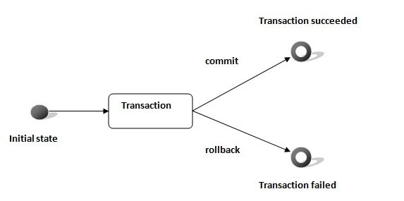

* **Có 4 tính chất ACID** (Atomicity, Consistency, Isolation and Durability)

<https://www.javatpoint.com/hibernate-transaction-management-example?fbclid=IwAR0CF1pRqV9fdJPegjkDxT-EONiEH_iqbTTcjZFaLf9sX9pv56So3Y3SgDo>

* Là interface (JTA, JDBC)

|  |  |
| --- | --- |
| **Method** | **Description** |
| session.beginTransaction() | associated with Session and init transaction |
| void begin() | starts a new transaction. |
| void commit() | ends the unit of work unless we are in FlushMode.NEVER |
| boolean wasCommited() | checks if the transaction is commited successfully. |
| void rollback() | forces this transaction to rollback. |
| boolean wasRolledBack() | checks if the transaction is rolledback successfully. |
| void setTimeout  (int seconds) | it sets a transaction timeout for any transaction started by a subsequent call to begin on this instance. |
| boolean isAlive() | checks if the transaction is still alive |
| void registerSynchronization  (Synchronization s) | registers a user synchronization callback for this transaction |

* **Default autocommit = false**

<https://stackoverflow.com/questions/23100888/why-is-hibernate-connection-autocommit-true-not-recommended-in-hibernate?fbclid=IwAR3pJld-6l4YZbs1_S4J41S4w5Bfs-UNo0HffHwBrhHKv5sydXAcaPAVtJ0>

<https://developer.jboss.org/wiki/Non-transactionalDataAccessAndTheAuto-commitMode?fbclid=IwAR0rbo810sTb_gRfx95NSTbAFtk4hG7hX5NFB-0BzegEBOvWRLPEXfriWQc>

* VD1:

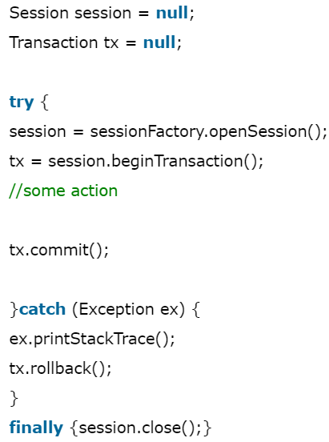

* VD2: CRUD transaction

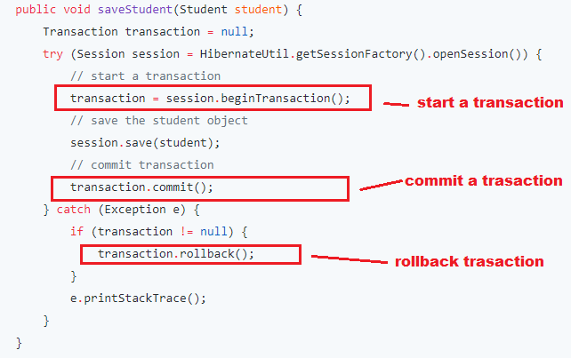

[*https://www.javaguides.net/2018/12/hibernate-transaction-management-tutorial.html?m=1&fbclid=IwAR19p7T3NuDPymO8mGnJho4X_Rr9ZGwKx4IlB7NtKGjHT0qKSmnkMp-8qlQ*](https://www.javaguides.net/2018/12/hibernate-transaction-management-tutorial.html?m=1&fbclid=IwAR19p7T3NuDPymO8mGnJho4X_Rr9ZGwKx4IlB7NtKGjHT0qKSmnkMp-8qlQ)

* **Reference**

<https://www.javatpoint.com/hibernate-transaction-management-example?fbclid=IwAR0CF1pRqV9fdJPegjkDxT-EONiEH_iqbTTcjZFaLf9sX9pv56So3Y3SgDo>